# Workshop 5 - CSY2085 – Server Administration and Security

## Workshop 5 – Windows Server Storage

**STUDENT NAME:**

**STUDENT NUMBER:**

Please use the same workstation for all your workshops, or you will not have access to the virtual machines that you have created previously.

## Windows Server Storage

Windows Server can work with hard disk storage in several different ways. The different types of physical hard disks that can be used are ATA (IDE), SATA, or SCSI. These are the different types of logical interfaces that the hard disks use to communicate with the computer system motherboard and thus the operating system. Most systems have an upper limit in the number of physical hard disks that they can accommodate.

However, each physical hard disk can be further divided up into several partitions, volumes or logical drives. For Windows Server 2019, making use of MBR, each hard disk can have either up to 4 primary partitions or 3 primary partitions and 1 extended partition. A primary partition can be used to boot an operating system such as Windows, but an extended partition cannot. An extended partition, however, can be further sub-divided into smaller logical drives.

There are additional rules for partitions, depending on the firmware used by the hard drives, and whether the PC uses BIOS or UEFI. For this workshop, we will be assuming a BIOS-based PC, using an MBR partition structure. If you wish to know more, detailed information can be found at this link to [Microsoft TechNet](https://technet.microsoft.com/en-us/library/dd799232%28v=ws.10%29.aspx?f=255&MSPPError=-2147217396) (Not required, but additional background reading if you wish to know more.) A glossary of terms is included at the end of this workshop.

A Windows Dynamic Disk can be configured as a single disk, or it can be used as part of a Spanned Volume, a Striped Volume, a Mirrored Pair or a RAID 5 set. These types of storage are explored in this workshop.

## Types of Disk Storage Arrangements

* Single Disk - this is the simplest and most common arrangement and often the default one used. It is the only option available if you have only one hard disk.
* Spanned Volume - this is a single logical volume constructed from more than one hard disk. This is the easiest way of increasing storage space, simply by adding more hard disks to the spanned volume. The down side with a spanned volume is that as soon as one hard disk fails, the whole spanned volume is destroyed and all the data on it lost.
* Striped Volume - this is a volume that stores data in stripes on two or more disks. Data in a striped volume is allocated alternately and evenly (in stripes) across the disks. Striped volumes potentially offer the best performance of all the different types of storage arrangements, but they do not provide fault tolerance. If a disk in a striped volume fails, the data in the entire volume is lost.
* Mirror Pair - this uses two disks to store the same piece of data, which means it requires twice the storage space to store the data. However, it offers good fault tolerance if one of the disks fails, the system will still work as normal with one disk.
* RAID 5 - this uses the equivalent of the space of one disk in the RAID-5 volume for storing enough data encoding information so that if one disk in the set was to fail, all the data would still be safe. This extra encoding information is spread across all the disks in the set and is recoverable from any of the disks in the set. The minimum number of disks for a RAID 5 set is 3.

## Task 1 - Creating and configuring a Simple Dynamic Disk

1. Locate and start the Windows Server you created and set up in the previous workshops.
2. Once started and logged in as the Administrator, right click on the Start button, and you should see a menu as shown below. Click “Disk Management”.

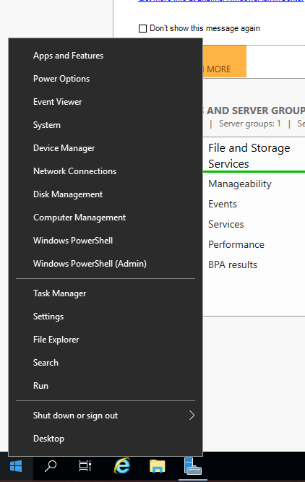

You should see a screen that looks like the window below:

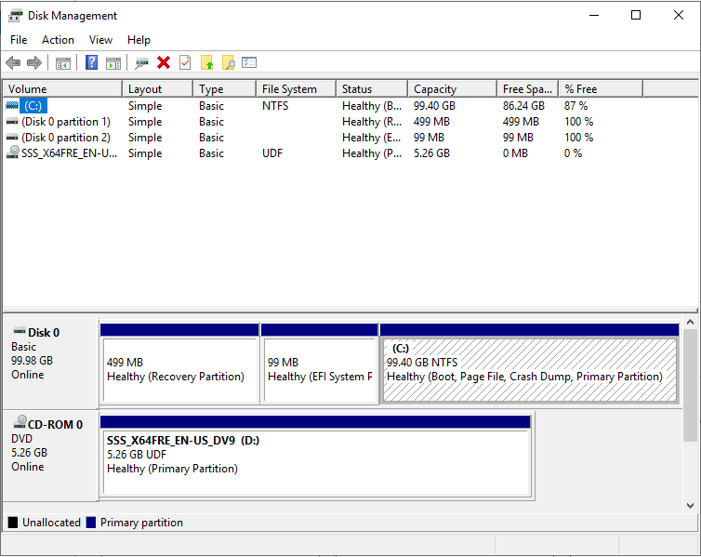

1. On the VMware Player window, click on "Player", then “Manage”, then "Virtual Machine Settings".
2. Click Add.

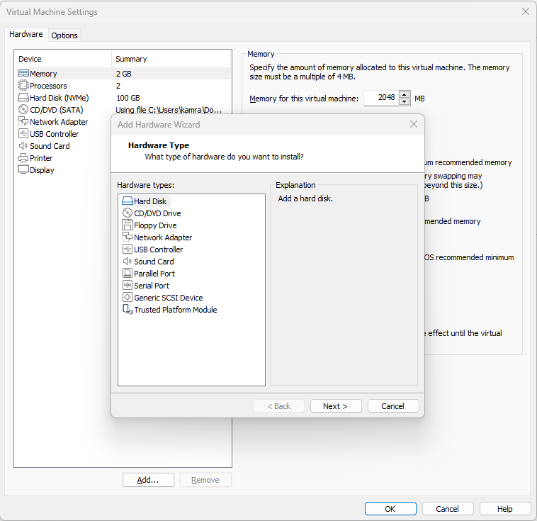

1. Then select Hard Disk, Next, select SCSI, and Next.
2. Select “Create A New Virtual Disk”, then click Next.

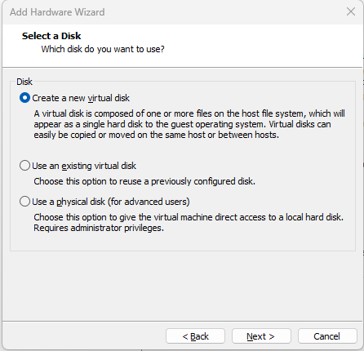

1. Set the size of the new hard disk to 1GB, and “Store virtual disk as a single file, and Next.

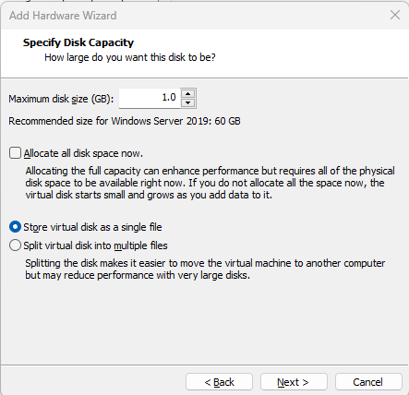

1. Name your new disk as Disk-1-yourstudent ID. So if your student ID is 1023456, name your new disk as Disk-1-1023456, and click Finish then click OK.

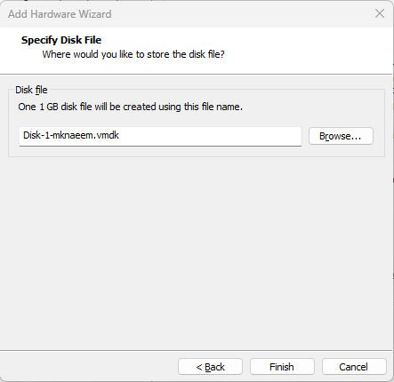

1. In your Disk Management screen you should now have an Unknown disk which is “Offline”. Right-click on it, and an option to bring it “Online” should be available. Click it. 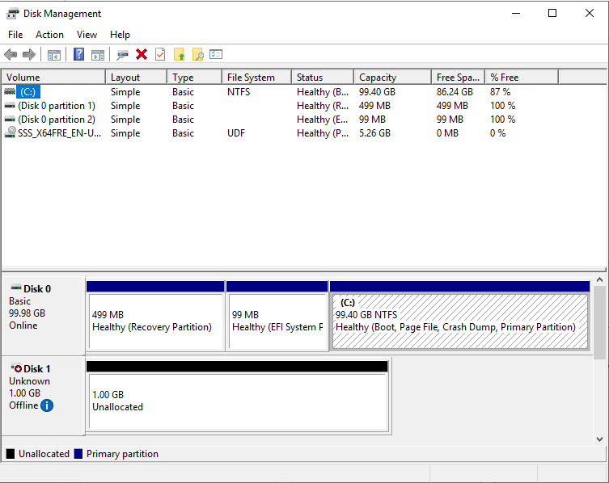

When it’s online, right click on it again, and select “Initialise Disk.”

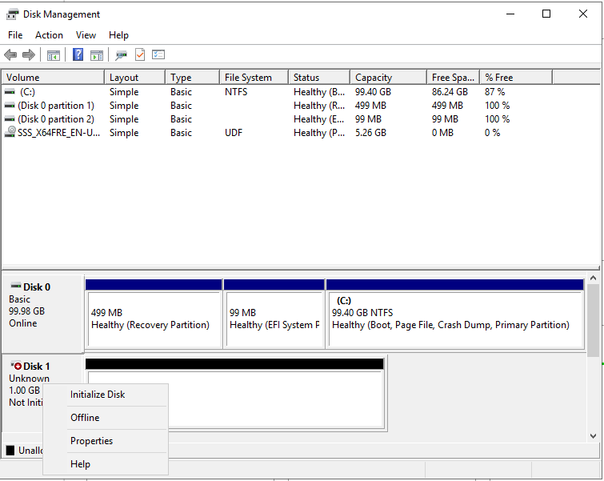

1. A window will pop up – select “MBR”, and “OK”.

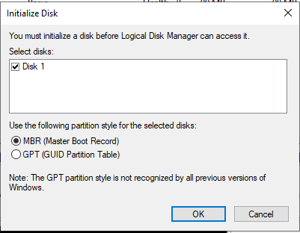

1. Once the disk has been initialised, Right click on it again, and “Convert to Dynamic Disk”:  
   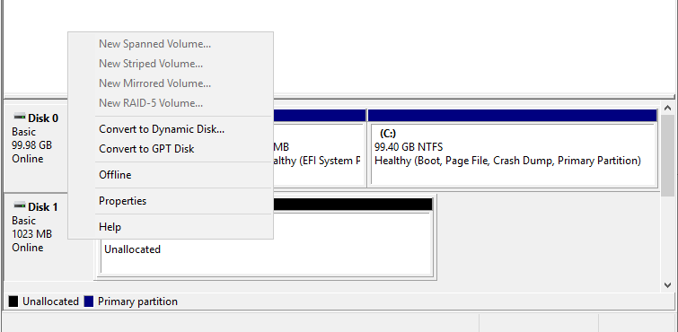
2. Another window will pop up; leave the default selected, and click “OK”.
3. Once converted, right click on the unallocated portion and create a New Simple Volume:  
   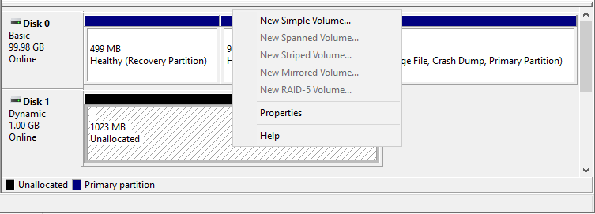
4. The subsequent screen, opt for the default size, and click “Next”.

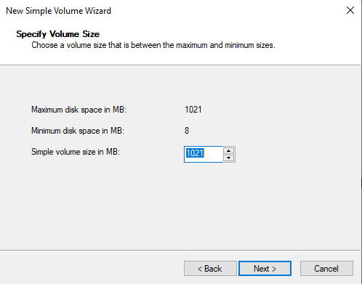

1. Assign it to the Drive letter “S”, click Next.
2. Call the volume name “Simple” and select a “Quick Format” with NTFS. Click “Next”, then “Finish”. When successful, you should end up with a screen like the following: 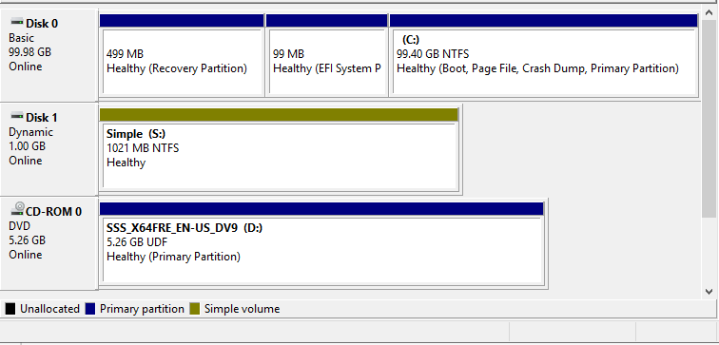
3. Now capture and paste your own screen below:  
     
   [Paste your screenshot here]

## Task 2 - Extending the Simple Disk to a Spanned Set

1. Create a text file called your-student-id.txt (eg. 1023456.txt) and save it onto drive S:
2. Create another 1GB disk. Initialise it. Convert it to dynamic, and called it “Disk-2-your-student-id” (eg. Disk-1-1023456). Do this by repeating Task 1 from Step 3 up to, and including Step 12.
3. You should end up with the following screen:  
   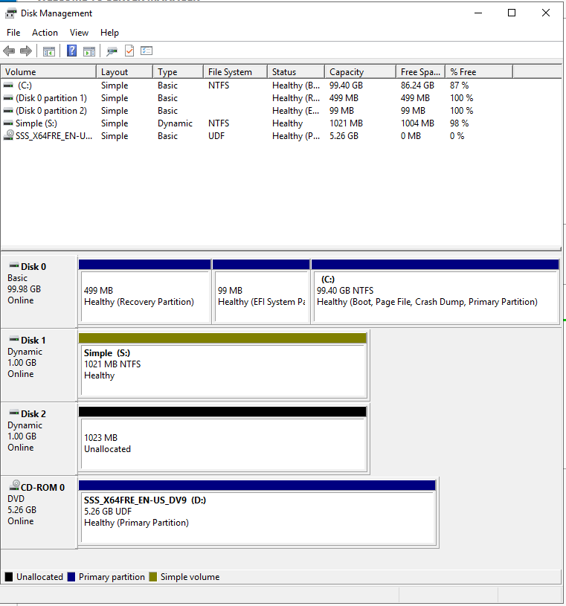
4. Now convert Drive S: into a Spanned Drive by right-clicking on it and selecting “Extend Volume”:  
     
   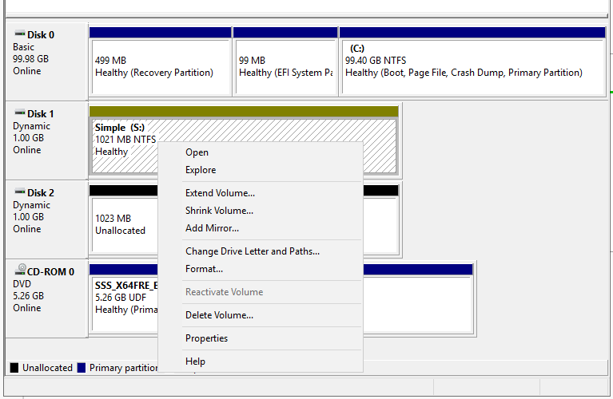
5. Select and add the new disk that you have just created:  
   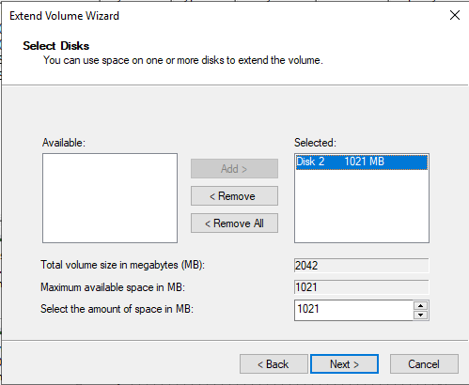
6. Once finished, confirm that you have now successfully extended the original 1GB Drive S: to a 2GB Spanned Drive by producing your own screen shot like the example below:  
   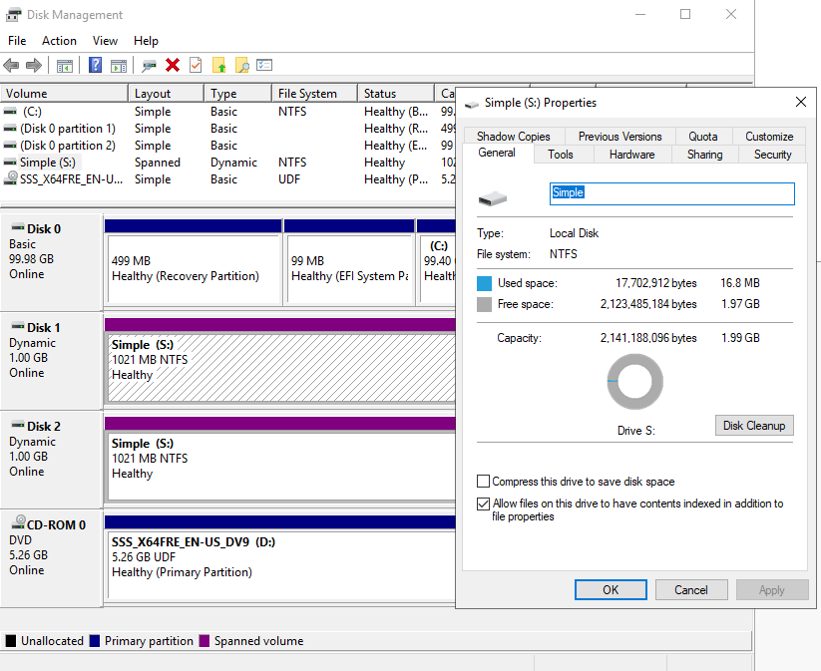  
     
   [Paste your own screen shot here]  
   **Question 1 – What happened to your original text file? Did it remain the same, or was it altered or deleted?**[your answer here]
7. Shutdown your Windows Server, go to edit the Virtual Machine Settings, and remove “Disk-2-your-student-id”.
8. Start your Windows Server again and answer the following question:  
     
   **Question 2 – What has happened to Drive S: and your text file?**   
     
   [your answer here]
9. Navigate to Disk Management, and capture your screenshot of it and paste it below:  
     
   [Paste your screenshot here]  
     
   **Question 3 – Does a Spanned Drive have any protection against disk failures?**   
     
   [your answer here]
10. Shutdown your Windows Server, go to edit the Virtual Machine Settings, and remove the“Disk-1-your-student-id”.

**Please Note: Remove only the 2 new drives that you have created in Task 1 and 2. Be careful not to remove your original drive, or you will have to re-install your server again.**

## Task 3 - Creating a Mirrored Disk

1. Using the steps in the previous tasks, create 2 Dynamic Disks (1GB size each) that are Initialised, but do not have any volumes. Name your disks “Disk-3-1234567” and “Disk-4-1234567” (substitute with your own ID numbers). You should end up with the following screen:  
   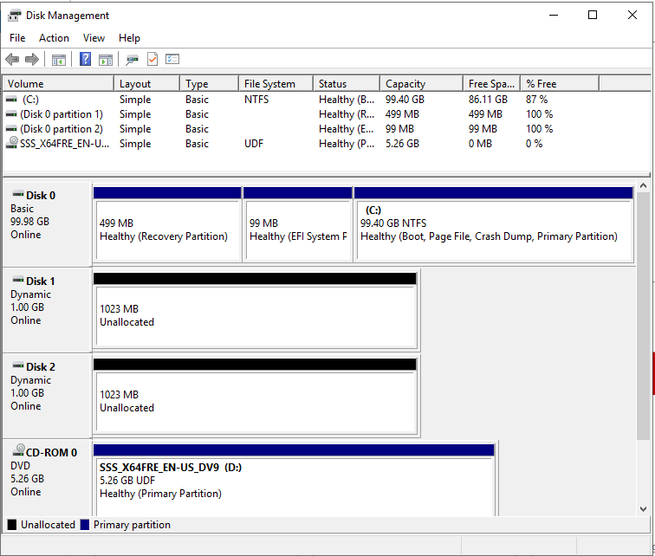
2. This time we will create a “Mirrored Volume” by right-clicking on an unallocated disk. Click “New Mirrored Volume”.

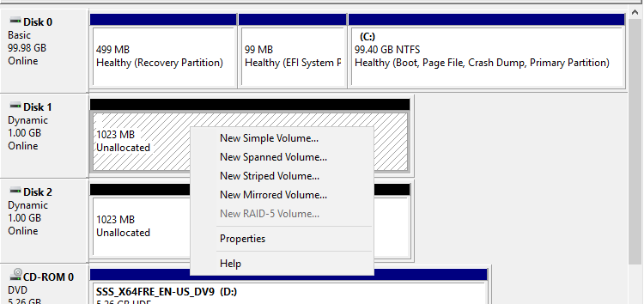

1. Then add both disks to the set:  
     
   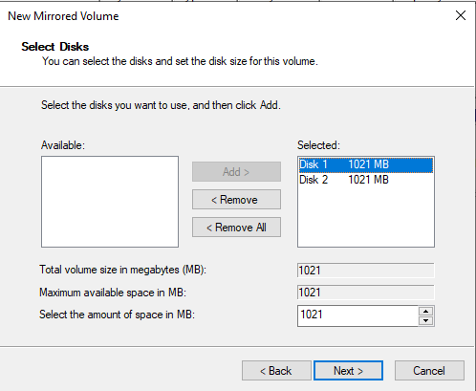
2. Set the Drive letter to “S” click Next, call the volume “Mirrored” and set it to quick format NTFS.
3. You should end up with a screen similar to:  
   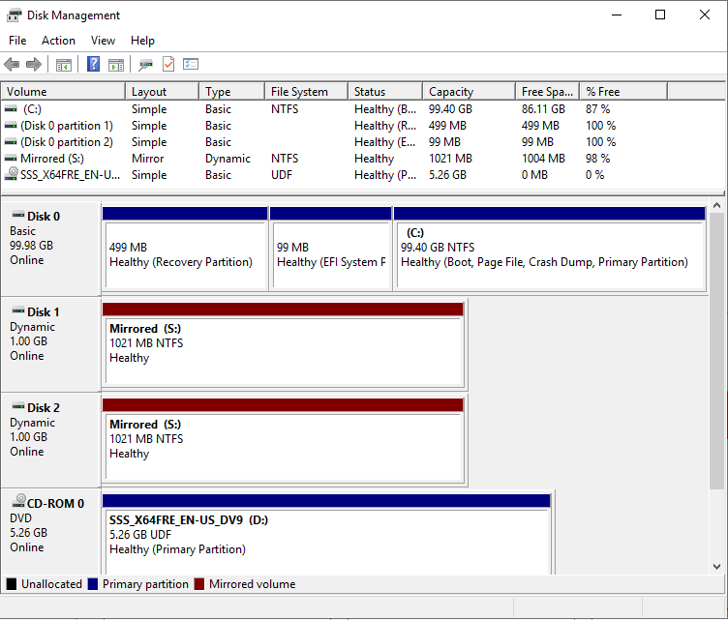
4. Paste your own screen shot below:  
     
   [Paste your screenshot here]
5. Now create your text file as before “12345767.txt” (substitute with your own ID) on Drive S:
6. Shutdown your Windows Server, go to edit the Virtual Machine Settings, and remove “Disk-4-your-student-id”.
7. Start your Windows Server again and answer the following question:  
     
   **Question 4 – What has happened to Drive S: and your text file?**  
     
   [your answer here]
8. Navigate to Disk Management, and capture your screenshot of it and paste it below:  
     
   [Paste your screenshot here]  
     
   **Question 5 – Does a Mirrored Drive have any protection against disk failures?**  
   [your answer here]

## Task 4 - Recovering from a failed Mirrored Disk

1. Shutdown your Windows Server, go to edit the Virtual Machine Settings, and create another new 1GB SCSI disk and then start your Windows Server.
2. Initialise and convert the new disk to Dynamic.
3. Next, you will need to break the mirror and remove the missing disk. Click on the S: drive (missing), then right click and select “Remove Mirror”.   
   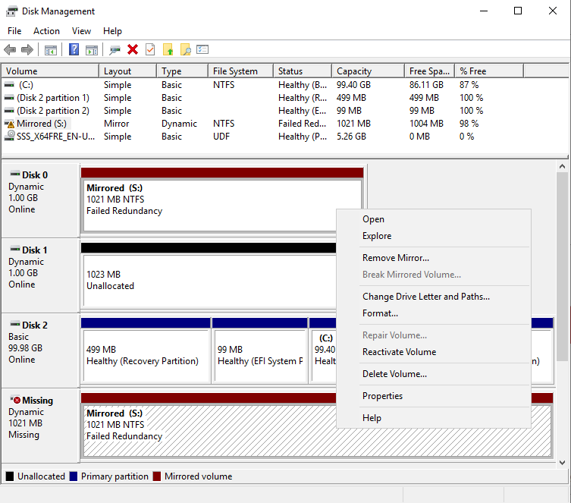
4. Select the missing disk and remove it.
5. Then repair the mirror by right clicking the S: drive and selecting “Add mirror” and then selecting your new disk.
6. Your Mirrored Disk should re-synchronise and repair itself.
7. Capture your screenshot confirming this and paste it below:  
     
   [paste your screenshot here]

**Question 6 – What has happened to your text file?**  
  
[your answer here]

1. Shutdown your server and remove the disks that you created in Task 4.

## Task 5 - Creating a RAID 5 Disk

1. Using the steps in Task 1, create 3 Dynamic Disks (1GB size each) that are Initialised, but do not have any volumes.
2. **Using what you have learnt** so far, create a RAID-5 Disk from the 3 new disks.
3. Paste your screenshot of the Disk Management screen here, similar to:

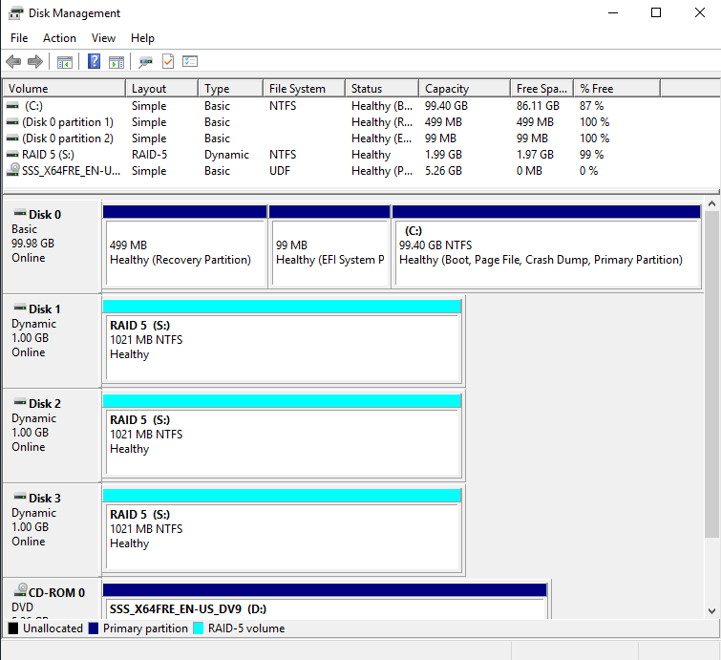  
  
[paste your screenshot here]

**Question 7 - What size is the resulting RAID-5 Disk?**

[your answer here]

1. By creating files and then removing a disk, answer the following question. **Question 8 – Does a RAID-5 Drive have any protection against disk failures?**   
     
   [your answer here]
2. Now shutdown your Windows Server and backup your server images as explained in Workshop 1.

## Task 5

Most organisations and data centres rely on some kind of networked storage. Research and explain the differences between DAS, NAS and SAN. How is RAID technology used in networked storage?

## Glossary of Terms

BIOS – BIOS (basic input/output system) is the program a PC uses to get the hardware initialised, and boot the operating system after you turn it on. It has several limitations, due to its age, and has been largely superseded by UEFI. As an example, as of January 2011 the largest hard drive BIOS can boot is 2.2TB.

UEFI - Unified Extensible Firmware Interface (UEFI, pronounced “oofy”) is the replacement to BIOS. It performs the same role as BIOS, but includes several improvements.

MBR - Master Boot Record (MBR) is a special boot sector located at the beginning of a drive. This sector contains a boot loader for the installed operating system, as well as information about the drive’s logical partitions. MBR only works with disks up to 2 TB in size. MBR also only supports up to four primary partitions, or three primary and one extended partition.

GPT - GUID Partition Table (GPT) is the replacement for MBR, as UEFI replaces BIOS. Windows allows up to 128 partitions on a GPT-compatible drive using GPT, without requiring extended partitions to make them work. Using GPT and UEFI, the maximum partition size is now 9.4 zettabytes. (That’s big.)

RAID - RAID (redundant array of independent disks) is a data storage virtualization technology that combines multiple hard drives into a single logical unit for the purposes of data redundancy, performance improvement, or both. This means that RAID can be used to safeguard data – or improve the performance accessing the data – or it can provide both. RAID has several levels that provide different levels of redundancy and / or performance improvement.